GPT2 Chatbot

1. Installation:

* Run command

git clone <https://github.com/hieunguyen7337/gpt2-chatbot.git>

cd gpt2-chatbot

pip install -r requirements.txt

* Download model weight file from link <https://drive.google.com/file/d/1PUY2VWWnTnkdoieC7H9bXQt0n9vpPOEH/view?usp=sharing> then put the file in the gpt2_model folder

1. Running chatbot

* Run the below command to run the chatbot on the terminal

python chatbot-offline.py

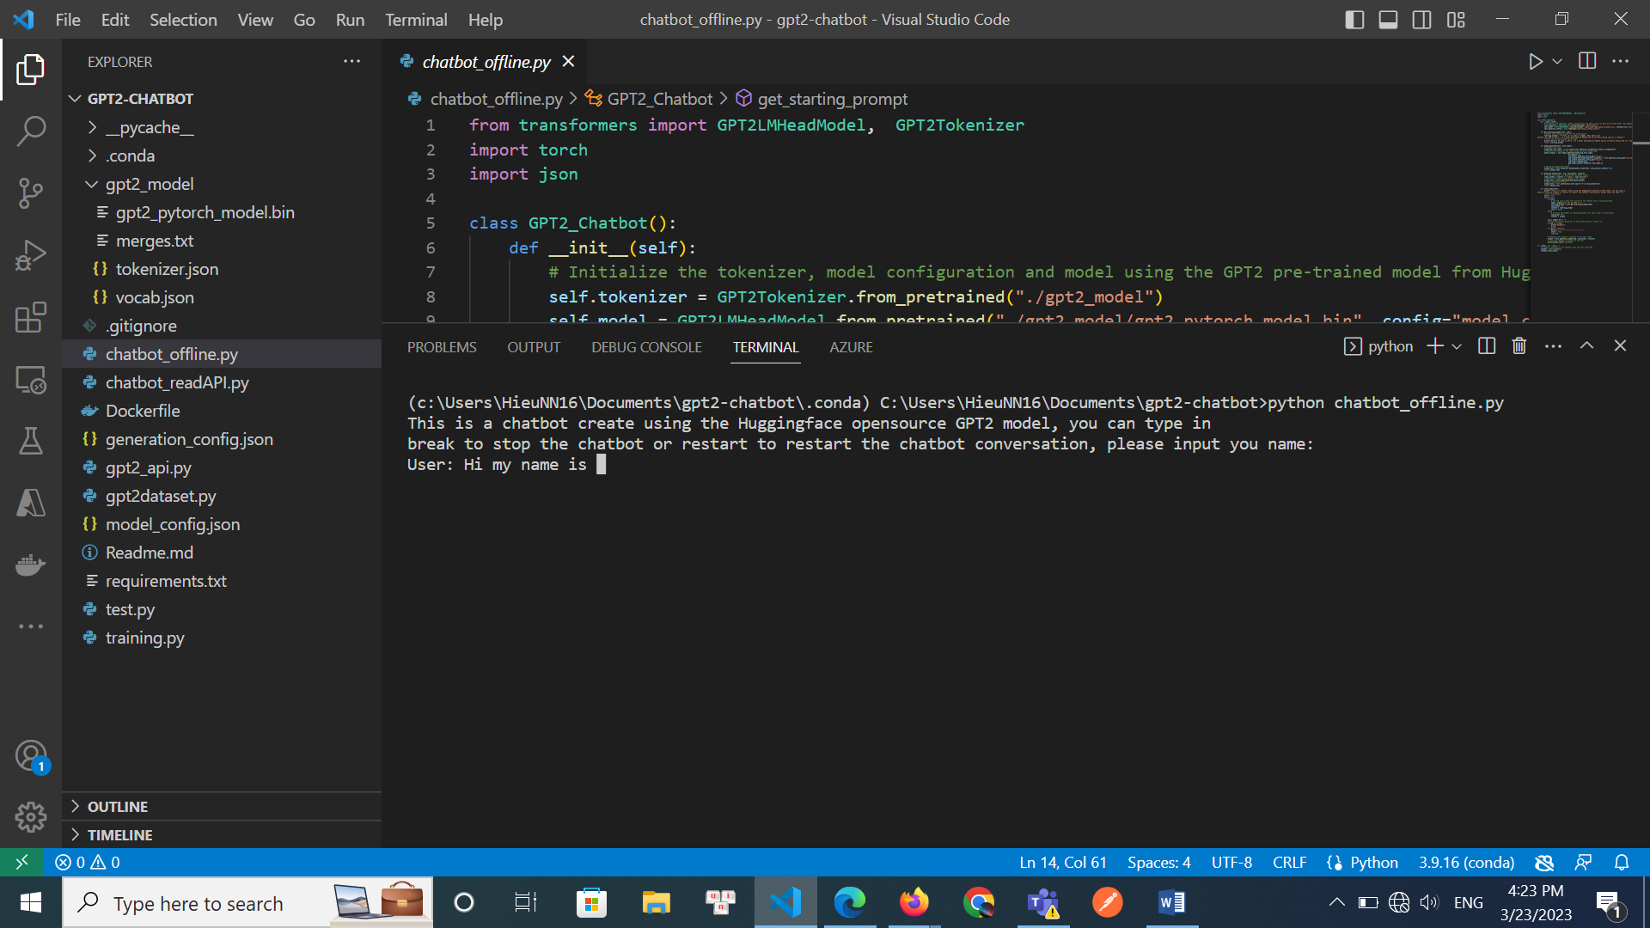

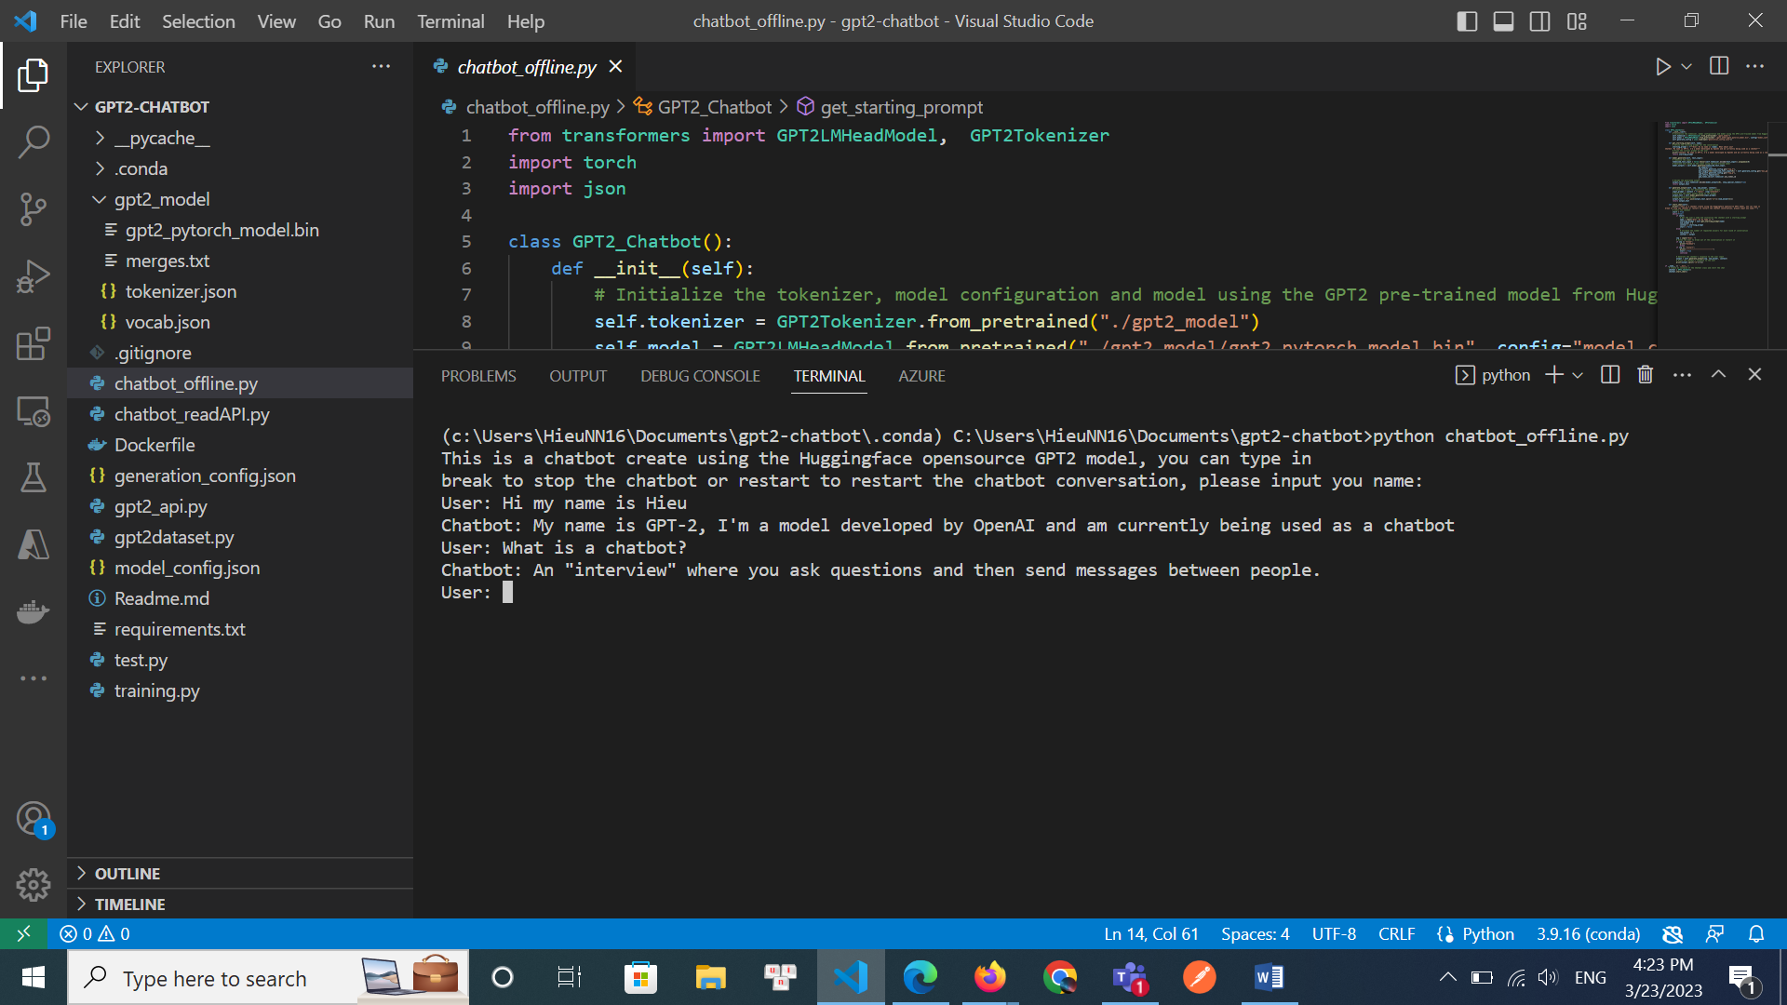

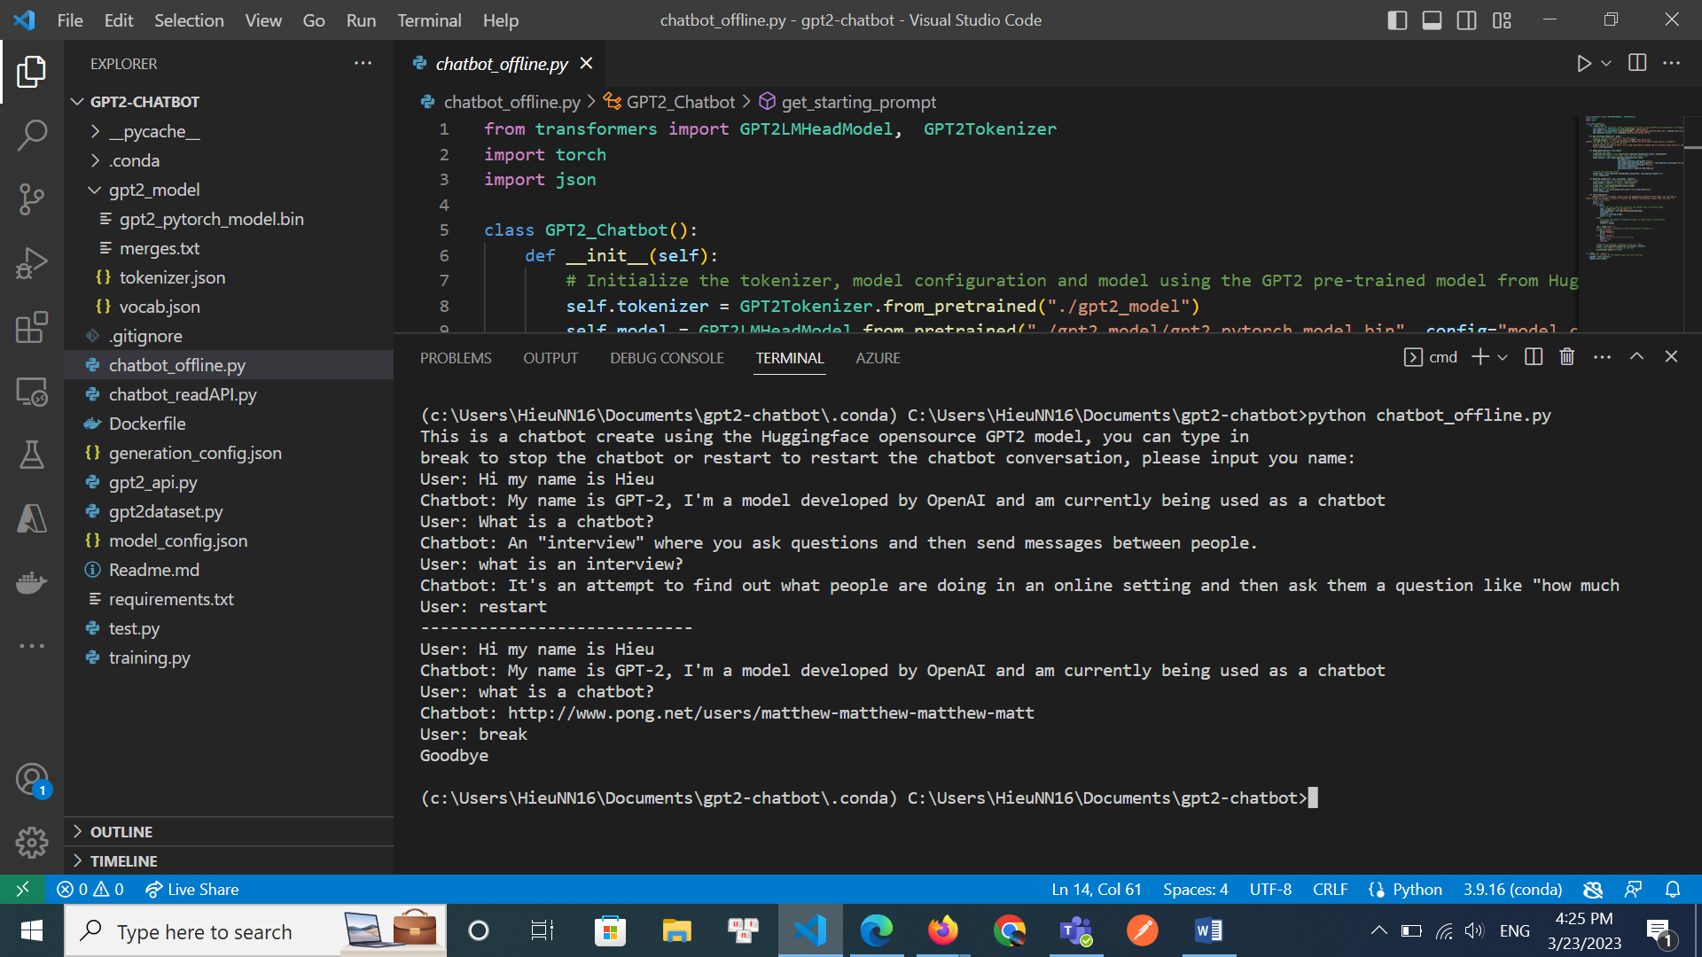

* Run the below command to start a Flask API server

python gpt2-API.py

API: \generate

Body: Json example:

{

    "text_input":"User: Hi my name is Hieu, What about you?\nChatbot: My name is GPT-2, I'm a model developed by OpenAI and am currently being used as a chatbot\nUser: What is a chatbot?\nChatbot:"

}

Response:

{

    "output":**Example output**

}

1. Configuration

* The chatbot use the pretrained GPT2-small model (117M parameters, 535MB model file), you can start the chatbot in terminal or start a Flask API with the model. The model is only a default pretrained model so for it to act as a chatbot we preprompt the model in the form of “User: … Chatbot: …”.
* The config file “model_config.json” contain the default config of the gpt2 model itself and is unchanged from the default value provided by huggingface.
* Another config file “generation_config.json” is the config file for the model generation process and contain 3 value top_p, top_k and max generation length.